FHICT-APP
Android 1 assignment
Kheir Almosally: 3039285

Contents
Application overview 3
FHICT API data Call 4
Extra features implemented 4
Git repository 5

Application overview
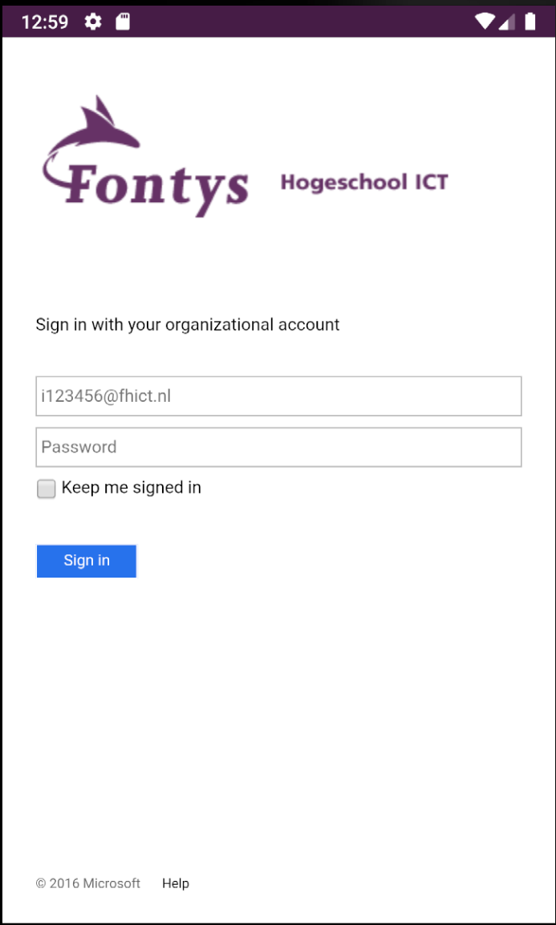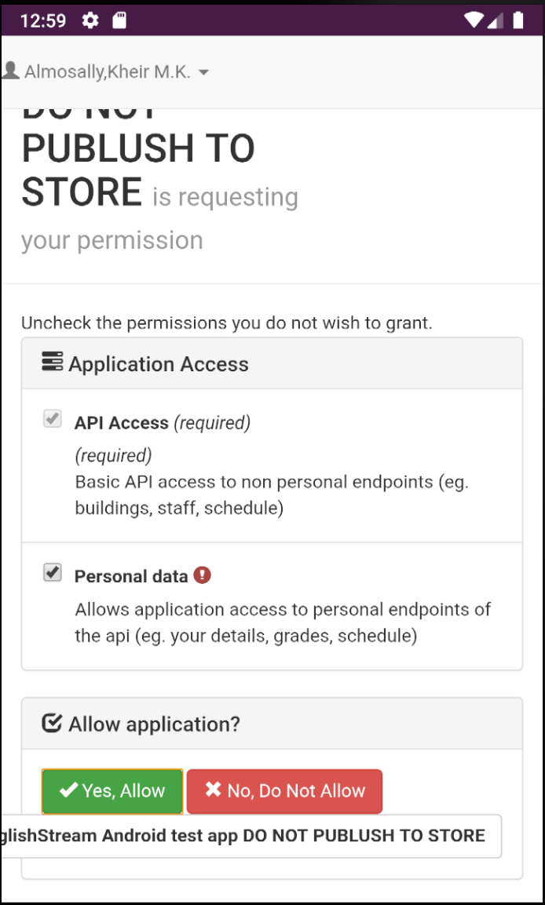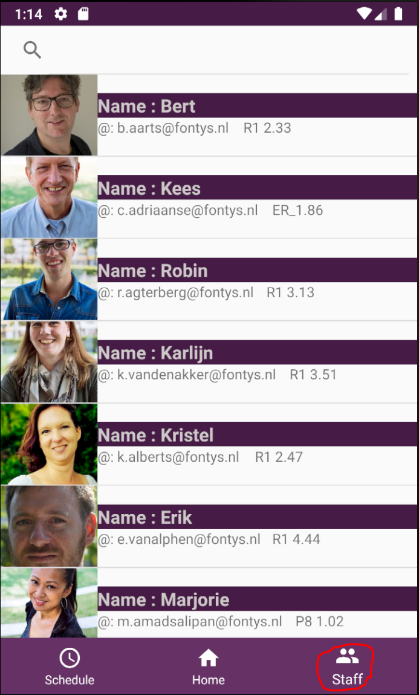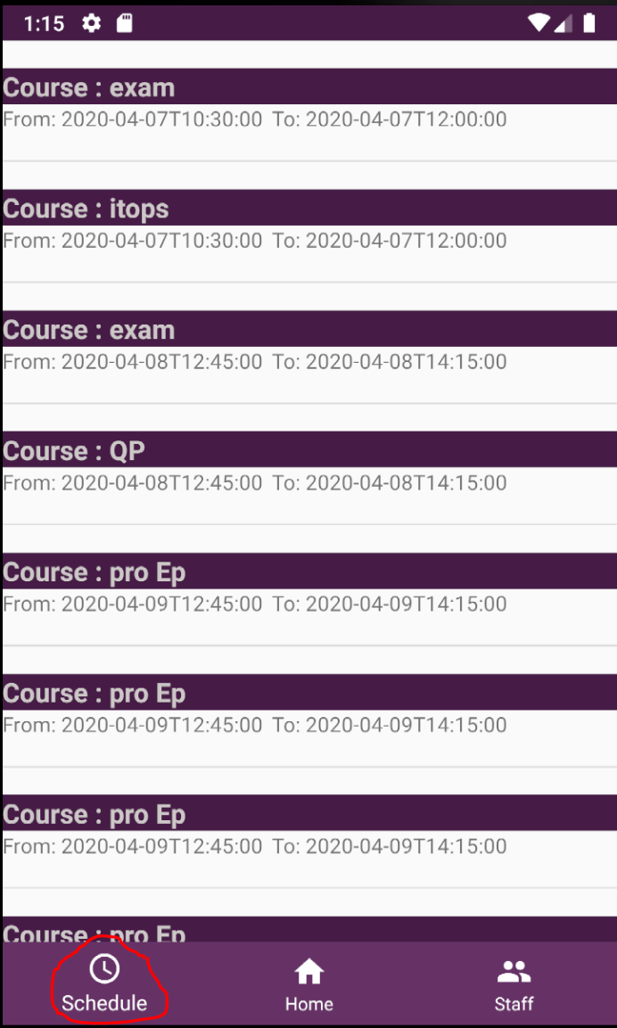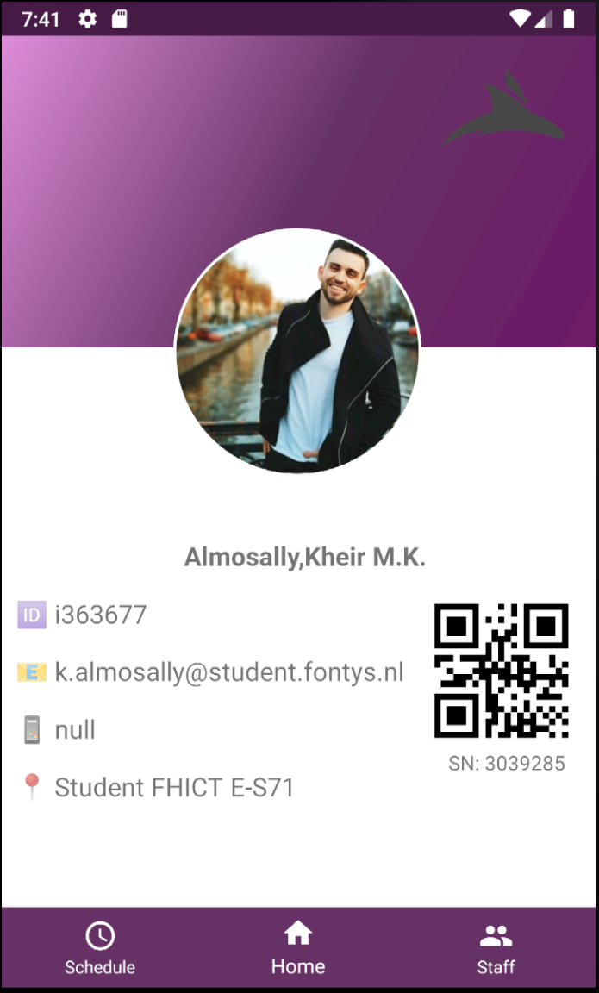

Home: Contain user information displayed {user’s picture, user’s name, PCN, Email, Phone number, Study section and class, QRCode contain student’s number,}
Stuff: List view display all teacher in the department of the student, search box to find a teacher by name.
Schedule: Contain all classes belong to student during his/her followed course and display course date and time.

FHICT API data Call
Four calls have been made to retrieve different information
User info : https://api.fhict.nl/people/me
Staff info: https://api.fhict.nl/people
User/Staff image call: https://api.fhict.nl/pictures/{username}.jpg supported by downloader code
Schedule info: https://api.fhict.nl/schedule/me?expandWeeks=true

Extra features implemented
Splash startup page: Show Fontys logo when the application launch for 2 second
Navigation component: For easy shuffle navigate between fragments, handling back stack and automatic fragments transaction. Simplify setup for navigation pattern, type safe argument passing.
Search box: In staff fragment for easy finding.
QR code: in case student forgot his ID and want to use in SSID or using a printer.
Image call: Create new image call retrieve image from URL

Git repository
https://git.fhict.nl/I369697/andr1

